April 4, 2017

Specialized Press Contact
Beate Adams
Communication
Silanes
Phone +49 6181 59-13628
Fax +49 6181 59-713628
beate.adams@evonik.com
Evonik Resource Efficiency GmbH
Rellinghauser Straße 1-11
45128 Essen
Phone +49 201 177-01
Fax +49 201 177-3475
www.evonik.com

Supervisory Board
Dr. Ralph Sven Kaufmann, Chairman

Executive Board
Dr. Claus Rettig, Chairman
Dr. Johannes Ohmer,
Simone Hildmann,
Alexandra Schwarz

Registered Office: Essen
Register Court: Essen Local Court
Commercial Registry B 25783
VAT ID no. DE 815528487

New environmentally friendly binder for zinc-rich paints

Dynasylan® SIVO 140 from Evonik, a new organic-inorganic binder for zinc-rich paints, is exceptionally safe for the environment yet easy to process. Coatings formulated with this binder are significantly more temperature resistant than those made with other organic binders. In addition, these products release virtually no volatile organic compounds (VOCs).

Dynasylan® SIVO 140 is produced using a hydrolysis and condensation method (the sol-gel process). The aqueous binder was specially developed for use in two-pack zinc dust paints. Zinc is usually added as the second component to the aqueous binder. Upon addition, the formulation cures at ambient temperature. Zinc-rich paints are the material of choice for long-term protection against corrosion in situations where other coatings reach their limits.

Due the way it has been designed Dynasylan® SIVO 140 can be used in the already existing equipment. Furthermore, the product has been optimized in order to allow easy formulation with a wide range of fillers and pigments. Also, depending on the application and need thin and thick coatings of the material can be made.

The processing time for any given application depends on the fillers and pigments used. On sand-blasted surfaces, typical formulations can be used for up to seven hours after preparation. The reactive silanol groups are activated during the drying process. This means that coatings are dry after a few minutes and completely cure within a few days. Typical heavy-duty anticorrosion applications include utility poles, industrial equipment, bridges, and ship exteriors.

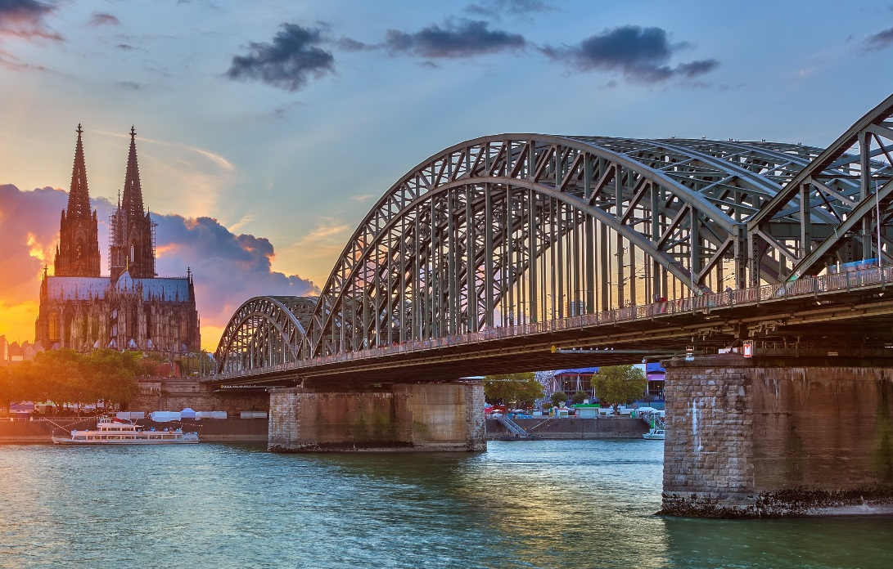
Caption:
Dynasylan® SIVO 140 from Evonik, a new organic-inorganic binder for zinc-rich paints, is exceptionally safe for the environment yet easy to process.

Company information
Evonik, the creative industrial group from Germany, is one of the world leaders in specialty chemicals. Profitable growth and a sustained increase in the value of the company form the heart of Evonik’s corporate strategy. Evonik benefits specifically from its innovative prowess and integrated technology platforms. Evonik is active in over 100 countries around the world with more than 35,000 employees. In fiscal 2016 the enterprise generated sales of around €12,7 billion and an operating profit (adjusted EBITDA) of about €2.165 billion.

About Resource Efficiency
The Resource Efficiency segment is led by Evonik Resource Efficiency GmbH and supplies high performance materials for environmentally friendly as well as energy-efficient systems to the automotive, paints & coatings, adhesives, construction, and many other industries. This segment employed about 9,000 employees, and generated sales of around €4.5 billion in 2016.

Disclaimer
In so far as forecasts or expectations are expressed in this press release or where our statements concern the future, these forecasts, expectations or statements may involve known or unknown risks and uncertainties. Actual results or developments may vary, depending on changes in the operating environment. Neither Evonik Industries AG nor its group companies assume an obligation to update the forecasts, expectations or statements contained in this release.

